Polynomials
1st Programming Techniques Assignment

Erhard Muresan
30232, 3rd Year
Computer Science
Technical University of Cluj Napoca

- Assignment Objective:

Propose a design and implement a polynomial calculator with a dedicated graphical interface through which the user can insert polynomials, select the mathematical operation (i.e., addition, subtraction, multiplication, division, derivative, integration) to be performed and view the result.

- Problem Analysis:

2.1 Domain Analysis

In order to solve the given task we first have to define the main processing operations of polynomials. So, we assume that the main operations with polynomials are the following mathematical operations:
- addition;
- subtraction;
- multiplication;
- division;
- the derivative;
- the integral;

Addition and subtraction are complementary operations, the only difference makes the sign of the coefficients of the second operator. Inverting the sign of each coefficient of the second operator and computing the addition operation will give us the result of the subtraction.
Multiplication and division of two polynomials can be computed by using the long division method, specific details of the method will be discussed later in this chapter.
The derivative and the integral are single polynomial operations.

Having established all the base operations performed with polynomials, we analyze each operation to understand how they work in order to create and implement the algorithms used for these operations. Of course there are many other operations, some of which could be considered for further development, operations such as: powers of polynomial, drawing the graph of polynomial and solving the root of polynomial(where possible).

Analyzing mathematical notation of the polynomial:

P(X) = a₀*X⁰ + a₁*X¹ + a₂*X² + … + a_{n-1}*X^{n-1} + a_{n}*X^{n}

We have used the following symbols in our notation:
  - P(X) is used for the name of the polynomial
  - a₀...a_{n} represents the coefficients of the polynomial
  - X^{1...n} represents the variable or indeterminate

After having an overview over the polynomial we should take each operation and discuss it individually:

  - Addition of two polynomials:

Given two polynomials P(X) and Q(X) adding resulting polynomial R(X). Combine like terms (same variables and the same exponents for these variables) using the distributive property b*a + c*a = (b+c)*a

P(X) = a₀*X⁰ + a₁*X¹ + a₂*X² + a₃*X³ + … + a_{n}*X^{n}
+
Q(X) = b₀*X⁰ + b₁*X¹ +b₂*X² + b₃*X³ + … + b_{n}*X^{n}
__________________________________________
R(X) = (a₀+b₀)*X⁰ + (a₁+b₁)*X¹ + (a₂+b₂)*X² + (a₃+b₃)*X³ + … + (a_{n}+b_{n})*X^{n}

We take the n-th coefficient of the first polynomial and add to it the coefficient of the same degree(index) of the second polynomial which result the n-th coefficient of the resulting polynomial

  - Subtraction of two polynomials:

Given two polynomials P and Q adding resulting polynomial R. Add the opposite of the second polynomial:

P(X) = a₀*X⁰ + a₁*X¹ + a₂*X² + a₃*X³ + … + a_{n}*X^{n}
-
Q(X) = b₀*X₀ + b₁*X¹ +b₂*X² + b₃*X³ + … + b_{n}*X^{n}
__________________________________________
R(X) = (a₀-b₀)*X⁰ + (a₁-b₁)*X¹ + (a₂-b₂)*X² + (a₃-b³)*X³ + … + (a_{n}-b_{n})*X^{n}

We take the n-th coefficient of the first polynomial and the coefficient of the same degree(index) of the second polynomial which will be the n-th coefficient of the resulting polynomial. We should be careful when creating the algorithm at the signs of each coefficient. At subtraction each sign of the coefficient should be reversed in the second polynomial and then added to the first polynomial coefficient.

  - Multiplication of two polynomials:

Given two polynomials P and Q adding resulting polynomial R. Use the distributive property
a(b+c) = ab + ac, laws of exponents, and addition and subtraction of polynomials

P(X) = a₀X⁰ + a₁X¹ + a₂X² + a₃X³ + … + a_{n}X^{n}
*
Q(X) = b₀X⁰ + b₁X¹ +b₂X² + b₃X³ + … + b_{n}X^{n}
__________________________________________
R(X) = a₀b₀X⁰⁺⁰ + a₀b₁X⁰⁺¹ + a₀b₂X⁰⁺² + … + a₀b_{n}X^{0+n} +
a₁b₀X¹⁺⁰ + a₁b₁X¹⁺¹ + a₁b₂X¹⁺² + … + a₁b_{n}X^{1+n} +
a₂b₀X²⁺⁰ + a₂b₁X²⁺¹ + a₂b₂X²⁺² + … + a₂b_{n}X^{2+n} +
+ a_{n}b₀X^{n+0} + a_{n}b₁X^{n+1} + a_{n}b₂X^{n+2} + … + a_{n}b_{n}X^{n+n}

We take the n-th coefficient of the first polynomial and multiply it with each coefficient from the second polynomial, applying also the distributive property and the law of exponents.

  - Division of two polynomials:

Given two polynomials P and Q adding resulting polynomial R. The division can be computed using two slightly different methods(actually one is derived from the other), respectively long division and synthetic division. The former implements the Euclidean division of polynomials. For the Euclidean division, a requirement is that the divisor must have the same or lower degree than the dividing polynomial. The long division method is represented in the following algorithm. Note that the long division works equally well if the dividend’s degree is less than the divisors degree, but the result in that case is the trivial Q = 0 and R = P(X) :
function n/d:
require d != 0
(q,r) ← (0, n)
while r != 0 and degree(r) >= degree(d):
t ← lead(r) / lead(d)
(q,r) ← (q+t, r-(t*d))
return (q,r)

/ - simple division
function n / d is
require d ≠ 0
q ← 0
r ← n // At each step n = d × q + r

while r ≠ 0 and degree(r) ≥ degree(d) do
t ← lead(r) / lead(d)
q ← q + t
r ← r − t × d

return (q, r)
+,-,* - polynomial operations

  - Derivative of a polynomial:

Given a polynomial P(X), the initial polynomial and R(X) the resulting derivative of the polynomial P(X):

P(X) = a₀X⁰ + a₁X¹ + a₂X² + a₃X³ + … + a_{n}X^{n}
R(X) = a_{1*1}X¹⁻¹ + a_{2*2}X²⁻¹+ a_{3*3}X³⁻¹ + ... + a_{n*n}X^{n-1}

  - Integration of a polynomial:

Given a polynomial P(X), the initial polynomial and R(X) the resulting integration of the polynomial P(X):

P(X) = a₀X⁰ + a₁X¹ + a₂X² + a₃X³ + … + a_{n}X^{n}
R(X) = a_{0/(0+1)}X⁰⁺¹ + a_{1/(1+1)}X¹⁺¹ + a_{2/(2+1)}X²⁺¹ + … + a_{n/(n+1)}X^{n+1}

2.1 Use Case

The main and the only actor in using the Polynomial Calculator is the user, requiring the ability to add, subtract, multiply, divide two polynomials, differentiate and integrate a polynomial. There can also be additional use cases which are not currently included in the requirements, but are common polynomial operations such as such as expansion(raising to power) and solving the roots(if possible) of the polynomial. Not included use cases can be considered as a further development objectives for the application.

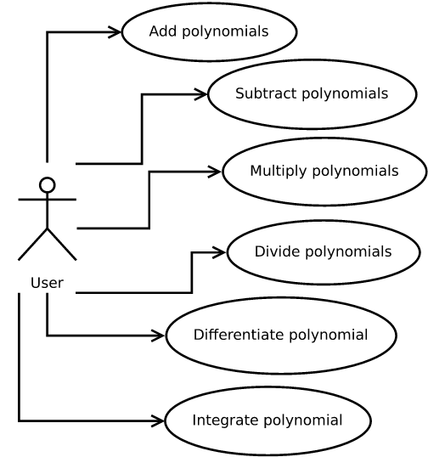

Use Case: Add polynomials
Primary Actor: user
Brief: The users gives two polynomials to get the result of the addition between the two
Main Success Scenario:
1. The user inserts two polynomials as input in form aX^0+bX^1..zX^n
2. Select order of operands (i.e. operation is applied to the first operand with the second operand, or reversed, although no different results, addition being commutative)
3. Select addition operation
4. The addition result is computed and displayed for the user
Alternative Sequence: Incorrect formatting
The user inserts incorrect format of the first polynomial, is displayed an error message.
The scenario returns to step 1. of the main scenario
The user inserts incorrect format of the second polynomial, is displayed an error message.
The scenario returns to step 1. of the main scenario.

Use Case: Subtract polynomials
Primary Actor: user
Brief: The user gives two polynomials to get the result of the subtraction between the two
Main Success Scenario:
1. The user insert two polynomials as input in form aX^0+bX^1+...+zX^n
2. Select order of operands(i.e. operation applies second operand to the first operand, or reversed)
3. Select subtraction operation
4. The subtraction result is computed and displayed for the user
Alternative Sequence: Incorrect formatting
The user inserts incorrect format of the first polynomial, is displayed an error message.
The scenario returns to step 1. of the main scenario
The user inserts incorrect format of the second polynomial, is displayed an error message.
The scenario returns to step 1. of the main scenario.

Use Case: Multiply polynomials
Primary Actor: user
Brief: The user gives two polynomials to get the result of the multiplication between the two
Main Success Scenario:
1. The user inserts two polynomials as input in form aX^0+bX^1+...+zX^n
2. Select order of operands (i.e. operation is applied to the first operand with the second operand, or reversed, although no different results, multiplication is commutative)
3. Select multiplication operation
4. The multiplication is computed and result is displayed for the user
Alternative Sequence: Incorrect formatting
The user inserts incorrect format of the first polynomial, is displayed an error message.
The scenario returns to step 1. of the main scenario
The user inserts incorrect format of the second polynomial, is displayed an error message.
The scenario returns to step 1. of the main scenario.

Use Case: Divide polynomials
Primary Actor: user
Brief: The user gives two polynomials to the result of the division between the two
Main Success Scenario:
1. The user inserts two polynomials as input in form aX^0+bX^1+...+zX^n
2. Select order of operands (i.e. operation is applied to the first operand with the second operand, or reversed)
3. Select division operation
4. The division is computed and result displayed to the user in form of Quotient and Remainder.
Alternative Sequence: Incorrect formatting or division by zero.
The user inserts incorrect format of the first polynomial, is displayed an error message.
The scenario returns to step 1. of the main scenario
The user inserts incorrect format of the second polynomial, is displayed an error message.
The scenario returns to step 1. of the main scenario.
The selects the divisor of value zero, an error message is displayed.
The scenario returns to step 1. of the main scenario.

Use Case: Differentiate polynomial
Primary Actor: user
Brief: The user gives a polynomial and gets the differentiation as result
Main Success Scenario:
1. The user inserts a polynomial(or two) as input in form aX^0+bX^1+...+zX^n
2. Selects operand for applying the operation
3. Selects differentiate operation
4. The differentiation is computed and result is displayed to the user
Alternative Sequence: Incorrect formatting
The user inserts incorrect format of the first polynomial, is displayed an error message.
The scenario returns to step 1. of the main scenario
The user inserts incorrect format of the second polynomial, is displayed an error message.
The scenario returns to step 1. of the main scenario.
Use Case: Integrate polynomial
Primary Actor: user
Brief: The user give a polynomial and gets the integration as result
Main Success Scenario:
1. The user inserts a polynomial(or two) as input in form aX^0+bX^1+...+zX^n
2. Selects operand for applying the operation
3. Selects integrate operation
4. The integration is computed and result is displayed to the user
Alternative Sequence: Incorrect formatting
The user inserts incorrect format of the first polynomial, is displayed an error message.
The scenario returns to step 1. of the main scenario
The user inserts incorrect format of the second polynomial, is displayed an error message.
The scenario returns to step 1. of the main scenario.

- Design

  - Data Structures

The data structure used to represent a polynomial is a list of its terms.

  - Class Design

The polynomial is represented with a list of its terms, each term being represented using the Monomial class. The Monomial class contains the exponent as an integer and the coefficient as a floating point number for representing a single term. The class implements getters methods for its members, namely coefficient() and exponent(). Additional useful methods are zero() to clear its values, overriding toString() to simplify displaying each term, equals(), compareTo(), and hashCode() for facilitating using the class in collections. The Polynomial class encapsulates a list of Monomial objects representing the actual polynomial. The Polynomial class has methods degree() to compute the degree of the polynomial, isZero() to check if it’s a zero term polynomial and collapse() which will purge all Monomial objects which have coefficient and

. Meth Its methods implements the operations add(Monomial), subtract(Monomia), multiply(Monomial), divide(Monomial), differentiate(Monomial) and integrate(Monomial) on the current objects and return a new Monomial object with the result. The Polynomial class represent multiple Monomial objects together and implements the PolyOps interface that has declared methods for addition, subtraction, multiplication, division, derivative and integrating two polynomials.

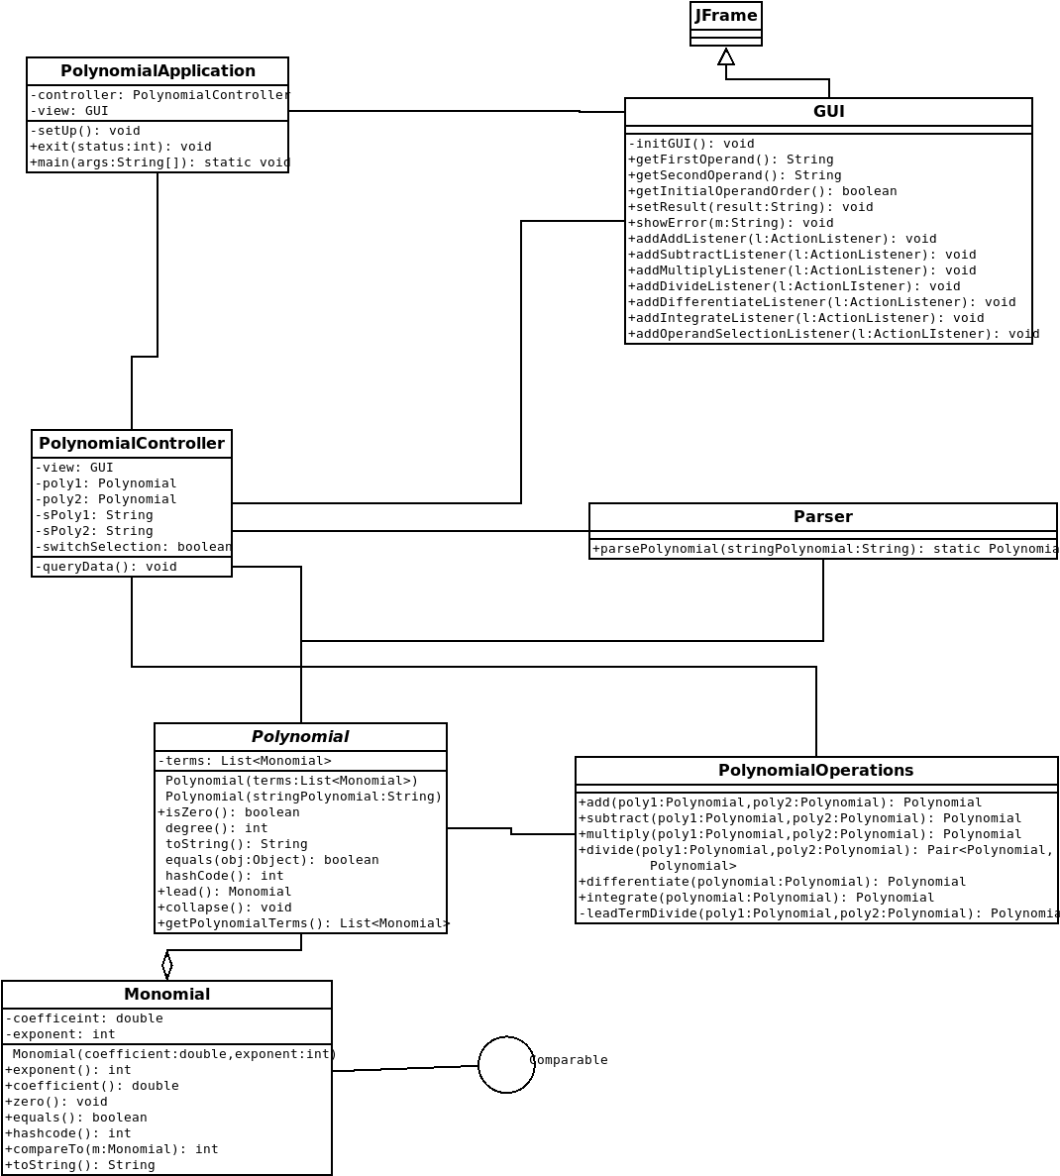

  - Interfaces

  - Relationships

The relationships between classes are realization, and aggregation. Realization is used by the Polynomial class implementing the PolyOps interface. Aggregation relationship is used between the Polynomial class and the Monomial class.

  - Packages

Using a Model-View-Controller architecture we divide the classes into three packages.
Polynomial, Monomial and PolyOps belong to the model package, PolynomialApplication and PolynomialController belong to the controller package and GUI belongs to the view package.
Other used packages are
org.javatuple, java.awt.BorderLayout, java.awt.FlowLayout, java.awt.event.ActionEvent, java.awt.event.ActionListener, javax.swing.BoxLayout, javax.swing.ButtonGroup, javax.swing.JButton, javax.swing.JFrame, javax.swing.JLabel, javax.swing.JOptionPane, javax.swing.JPanel, javax.swing.JRadioButton, javax.swing.JTextField.

  - Algorithms

Following algorithms are used in this project. Note that the list is not exhaustive:

public Polynomial add(Polynomial poly) {
List<Monomial> polyCopy = new ArrayList<>(poly.terms);
List<Monomial> thisCopy = new ArrayList<>(terms);
List<Monomial> polyVisited = new ArrayList<>();
List<Monomial> thisVisited = new ArrayList<>();
List<Monomial> result = new ArrayList<>();

thisCopy.forEach( first -> {
polyCopy.forEach( second -> {
if ( first.exponent() == second.exponent() ) {
result.add(first.add(second));
thisVisited.add(first);
polyVisited.add(second);
}
});
});
thisCopy.removeAll(thisVisited);
polyCopy.removeAll(polyVisited);
result.addAll(polyCopy);
result.addAll(thisCopy);
Polynomial pResult =new Polynomial(result);
pResult.collapse();
return pResult;
}

public Pair<Polynomial, Polynomial> divide(Polynomial poly) throws IllegalArgumentException {
this.collapse();
poly.collapse();
Polynomial dividend = this;
Polynomial divisor = poly;
Polynomial quotient;
Polynomial remainder;
Polynomial temp;
Pair<Polynomial,Polynomial> result;

if ( divisor.isZero() ) {
throw new IllegalArgumentException("Divisor polynomial should not be zero(0)!");
}
List<Monomial> zeroTerms = new ArrayList<>();
zeroTerms.add(new Monomial(0,0));
quotient = new Polynomial(zeroTerms);
remainder = dividend;
while ( !remainder.isZero() && (remainder.degree() >= poly.degree()) ) {
temp = remainder.singleTermDivide(divisor);
quotient = quotient.add(temp);
remainder = remainder.subtract(temp.multiply(divisor));
}
quotient.collapse();
remainder.collapse();
result = Pair.with(quotient,remainder);
return result;
}

public Polynomial differentiate() {
List<Monomial> copyThis = new ArrayList<>(terms);
List<Monomial> result = new ArrayList<>();

for ( Monomial term : copyThis ) {
Monomial mon = term.differentiate();
result.add(mon);
}
Polynomial pResult = new Polynomial(result);
pResult.collapse();
return pResult;
}

public Polynomial integrate() {
List<Monomial> copyThis = new ArrayList<>(terms);
List<Monomial> result = new ArrayList<>();

for ( Monomial term : copyThis ) {
Monomial mon = term.integrate();
result.add(mon);
}
Polynomial pResult = new Polynomial(result);
pResult.collapse();
return pResult;
}

public boolean isZero() {
boolean zero = true;
if ( terms.isEmpty() ) {
zero = true;
} else {
for ( Monomial term : terms ) {
if ( term.coefficient() != 0 ) {
zero = false;
}
if ( term.exponent() != 0 ) {
zero = false;
}
}
}
return zero;
}

  - Graphical User Interface

The Graphical User Interface is quite intuitive, being simple and precise. Each warning message also gives the exact nature of the error, trying to avoid ambiguous messages.

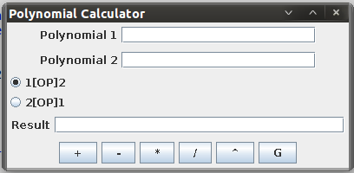

- Implementation and Testing

  - Implementation

The implementation is in Java programming language, using the object oriented paradigm. It uses standard libraries for Graphical User Interface, avoiding any portability problems it may cause. It doesn't use any external libraries to Java Standard Edition 6

  - Testing

It was tested how the parsing is done:

- Results

Addition:

Subtraction:

Multiplication:

- Conclusion

I personally learned in this assignment to think how to design a clear and simple design, without trying to use complicated relationships, implementations or algorithms. I tried, yet not convinced myself of achievement, to use the MVC design pattern. I'm still learning all the bits about it and I'm not really sure how I should implement such a pattern. But it opens me a road to all the common design patterns which I would like to explore.
Also I found myself clumsy at writing the documentation, now knowing how I should present my design, how much detail should it contain, which steps should I take to make it easy to understand, showing me another part to seek improvements.

6.1 Further Development

Further development for the polynomial calculator could be implementing the division, to power and the graph operations. The graph operation could be a great tool at understanding the resulted polynomial more easy looking at a visual representation of it.

- Bibliography

    - Operations on Polynomials - Algebra&Trigonometry Review, Wake Forest University
www.math.wfu.edu/Math105/Operations%20on%20Polynomials(revised).pdf
    - https://en.wikipedia.com/wiki/Polynomial_long_division/

Operations on Polynomials - Algebra&Trigonometry Review, Wake Forest University

